Lab # 07

System Programming



Teacher | Bibi Areej Khan
Student Name | Muhammad Ahmad Khan
Registration No | 23JZBCS0238

Department of CS&IT
University of Engineering and Technology Peshawar
(Jalozai Campus)

Lab Tasks: Processes in Linux (File System Calls)

Lab Task 1: File Copy Implementation

Objective
- To implement file copying using low-level Linux system calls.
- To understand and use open(), read(), write(), and close().
- To perform buffered file I/O operations.
- To handle errors using appropriate system-level mechanisms.

Theory
In Linux, all devices and files are treated uniformly and accessed through file descriptors (FDs). A file descriptor is an integer that uniquely identifies an open file within a process.
The system calls used are:
- open()
Opens a file and returns a file descriptor. It specifies access modes such as read-only or write-only.
- read()
Reads data from a file descriptor into a buffer. It may return fewer bytes than requested, especially at end-of-file (EOF).
- write()
Writes data from a buffer to a file descriptor. It returns the number of bytes successfully written.
- close()
Closes the file descriptor and releases system resources.
Buffered reading improves performance by reducing the number of system calls. Proper error handling is essential, as each system call returns -1 on failure and sets errno.

Program
#include <stdio.h>
#include <fcntl.h>
#include <unistd.h>

int main(int argc, char *argv[])
{
int source_fd, dest_fd;
char buffer[100];
int bytes_read;

if (argc != 3)
{
printf("Usage: %s source destination\n", argv[0]);
return 1;
}

source_fd = open(argv[1], O_RDONLY);
if (source_fd < 0)
{
perror("Error opening source file");
return 1;
}

dest_fd = open(argv[2], O_WRONLY | O_CREAT | O_TRUNC, 0644);
if (dest_fd < 0)
{
perror("Error opening destination file");
close(source_fd);
return 1;
}

while ((bytes_read = read(source_fd, buffer, sizeof(buffer))) > 0)
{
write(dest_fd, buffer, bytes_read);
}

close(source_fd);
close(dest_fd);

printf("File copied successfully\n");

return 0;
}

Output

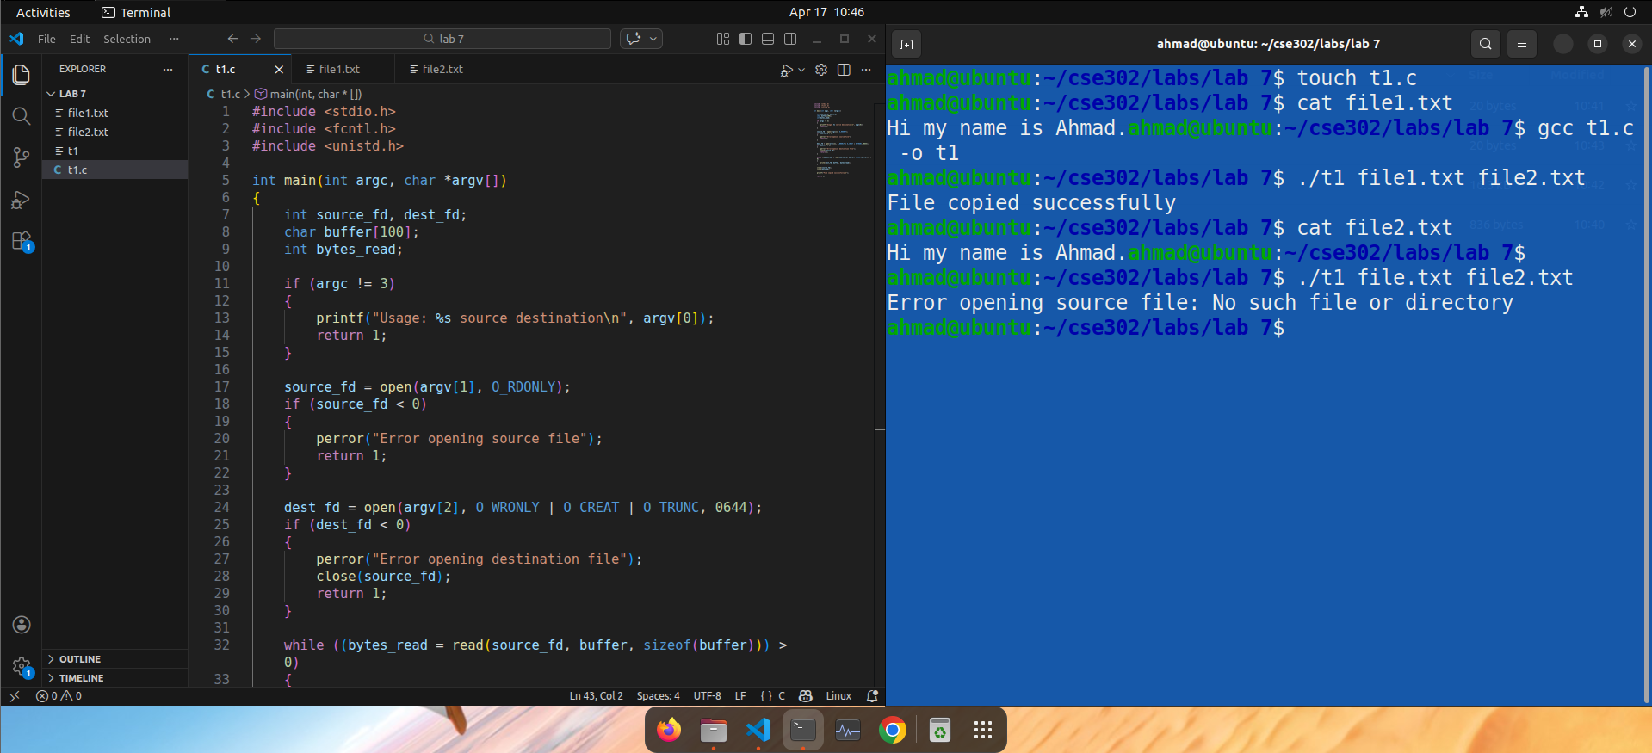

Lab Task 2: File Deletion

Objective
- To delete a file using the unlink() system call.
- To understand file removal at the system level.
- To implement proper error handling.
Theory
The unlink() system call removes a file from the filesystem by deleting its directory entry. If the file does not exist or cannot be accessed, the function returns -1 and sets errno.
This system call behaves similarly to the Linux rm command.

Program
#include <stdio.h>
#include <unistd.h>

int main(int argc, char *argv[])
{
if (argc != 2)
{
printf("Usage: %s filename\n", argv[0]);
return 1;
}

if (unlink(argv[1]) == -1)
{
perror("Error deleting file");
return 1;
}

printf("File deleted successfully.\n");
return 0;
}

Output
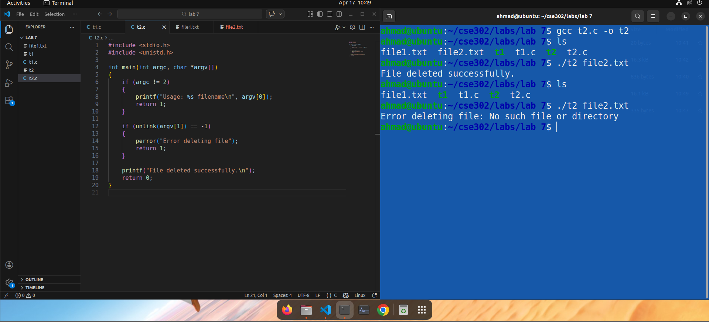

Lab Task 3: File Rename/Move

Objective
- To rename or move a file using the rename() system call.
- To handle cases where the source file does not exist.
- To display meaningful error messages using perror().

Theory
The rename() system call is used to change the name or location of a file. It can be used both for renaming within the same directory and moving files across directories.
If the source file does not exist, the call fails. If the destination exists, behavior depends on the system (typically overwritten).
This call functions similarly to the Linux mv command.

Program
#include <stdio.h>
#include <unistd.h>

int main(int argc, char *argv[])
{
if (argc != 3)
{
printf("Usage: %s source_file destination_file\n", argv[0]);
return 1;
}

if (rename(argv[1], argv[2]) != 0)
{
perror("Error moving/renaming file");
return 1;
}

printf("File moved/renamed successfully.\n");
return 0;
}

Output
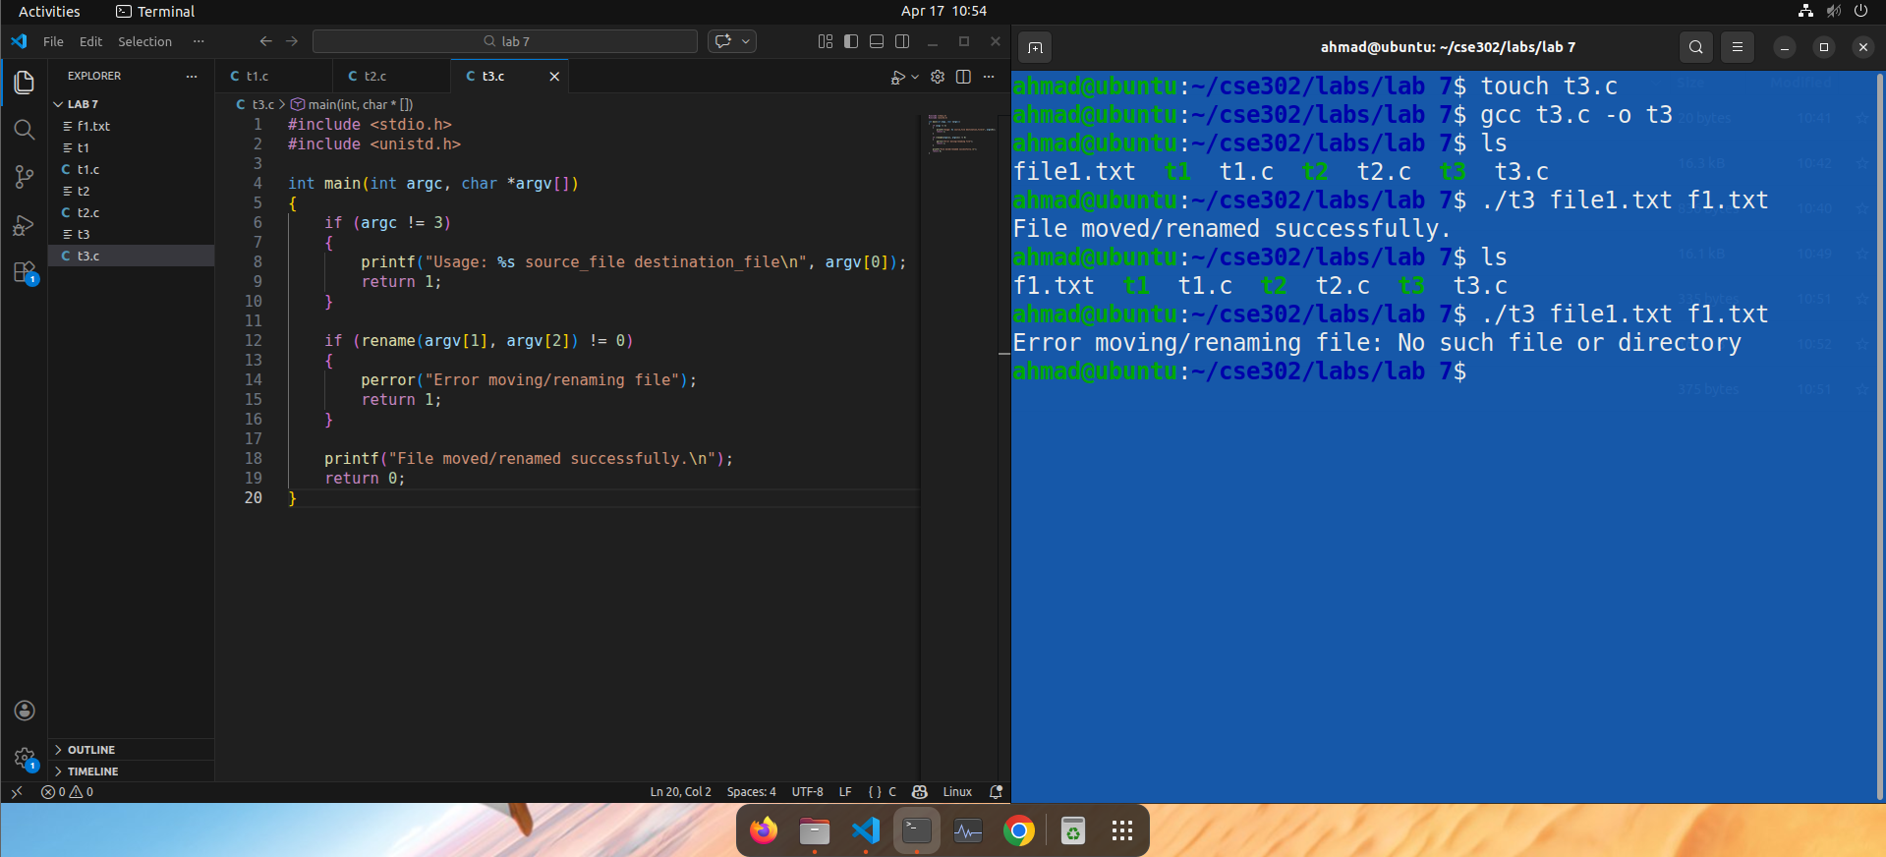

Conclusion
This lab provided practical exposure to Linux system calls for file manipulation. The implementation of file copy, deletion, and renaming demonstrated how low-level I/O operations are handled using file descriptors.
The use of open(), read(), write(), and close() reinforced understanding of buffered file operations and resource management. Additionally, unlink() and rename() illustrated how file system changes are performed at the system level.
Proper error handling using perror() and errno was essential in ensuring robustness. Overall, the lab strengthened understanding of device-independent I/O and core UNIX file handling mechanisms.

